1. How to compare two JSON have the same properties without order?
   1. var obj1 = { name: "Person 1", age:5 };
   2. var obj2 = { age:5, name: "Person 1" };

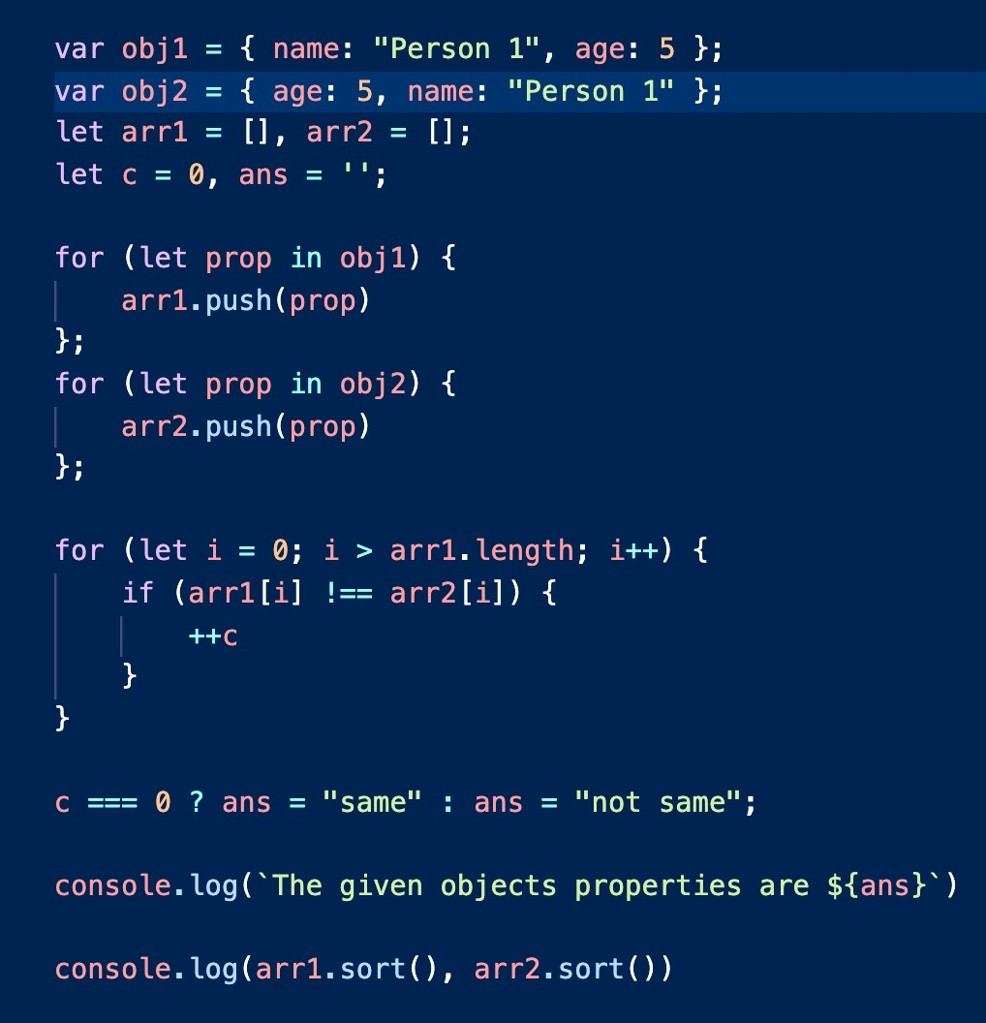Ans: Code:

Console:

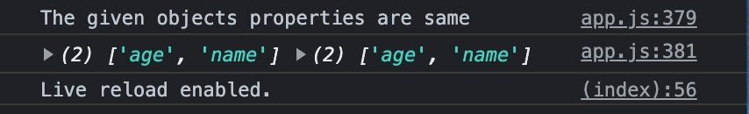

1. Use the rest countries API URL -> <https://restcountries.eu/rest/v2/all>and display all the country flags in the console

Ans:

Code:

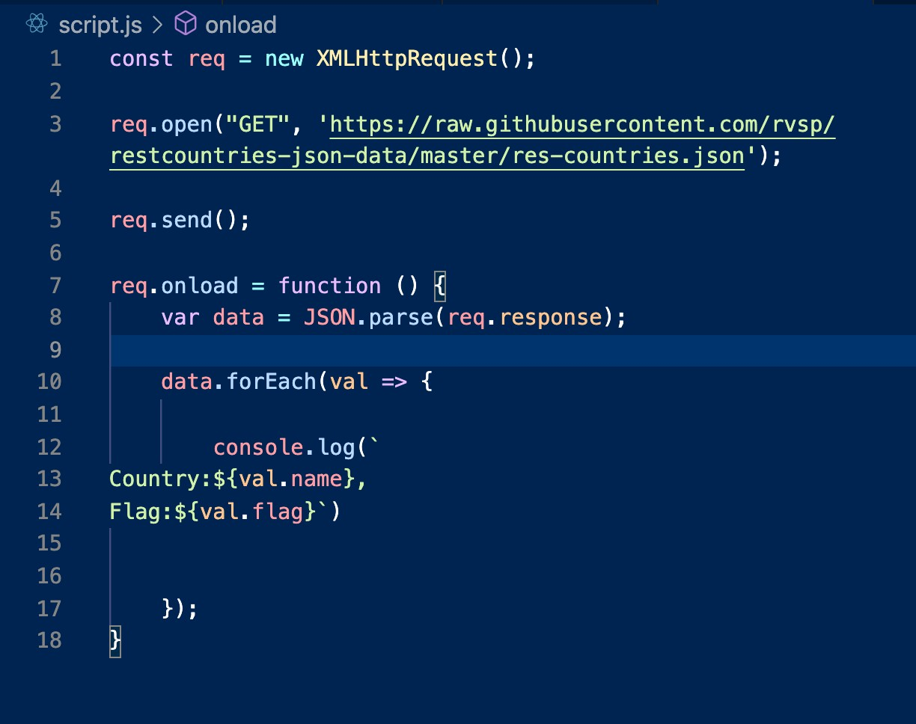

Console:

The scroll down for the console image.

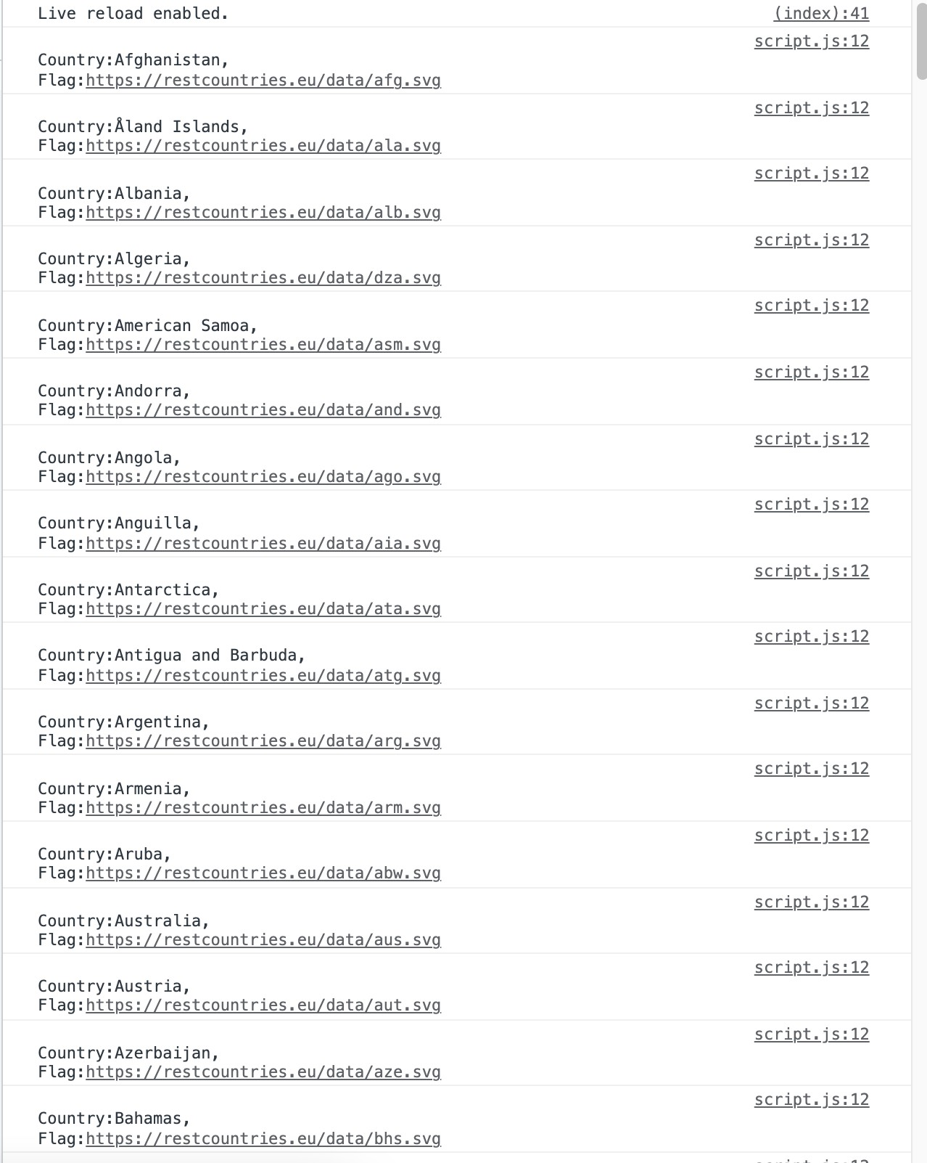

Scroll down for the next question.

1. Use the same rest countries and print all country's name, region, sub-region, and populations.

Ans:

Code:

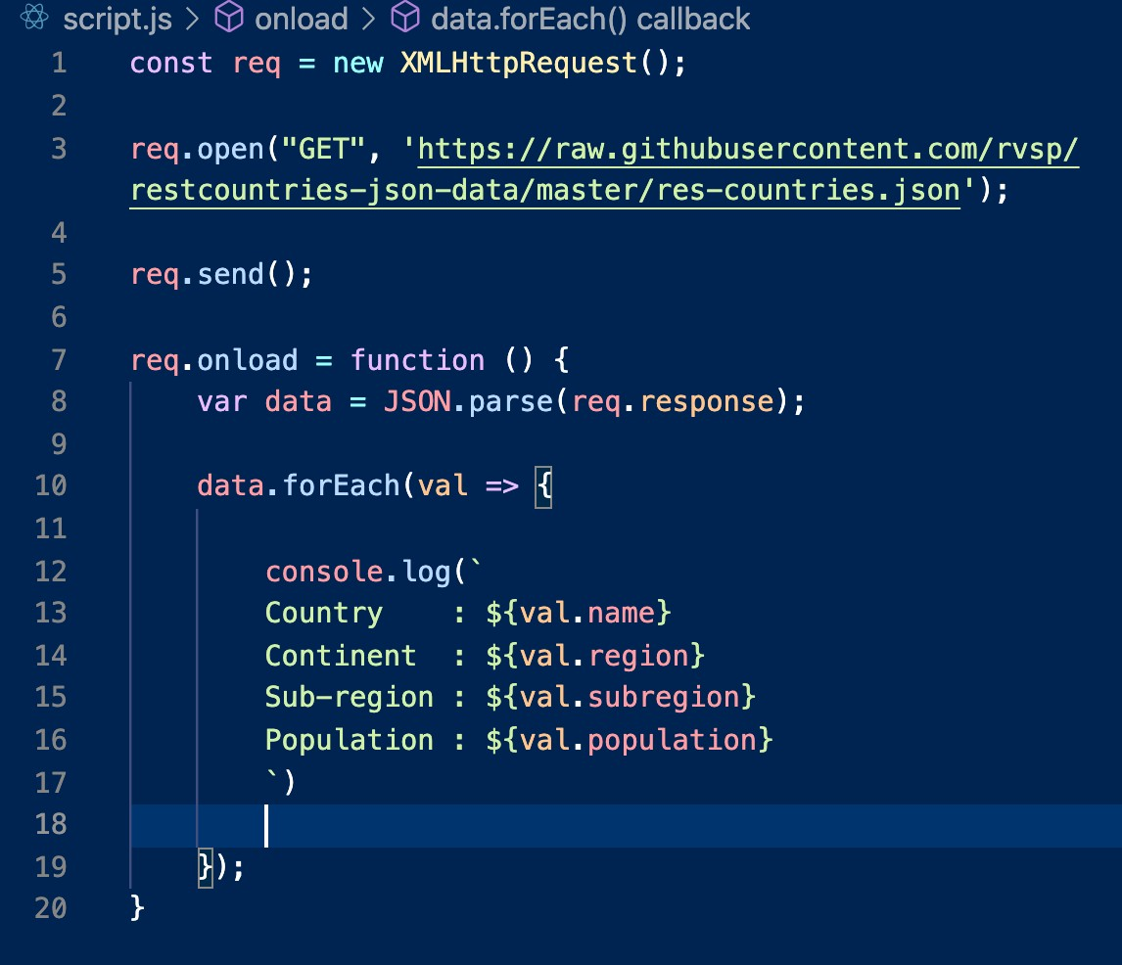

Console:

The scroll down for the console image.

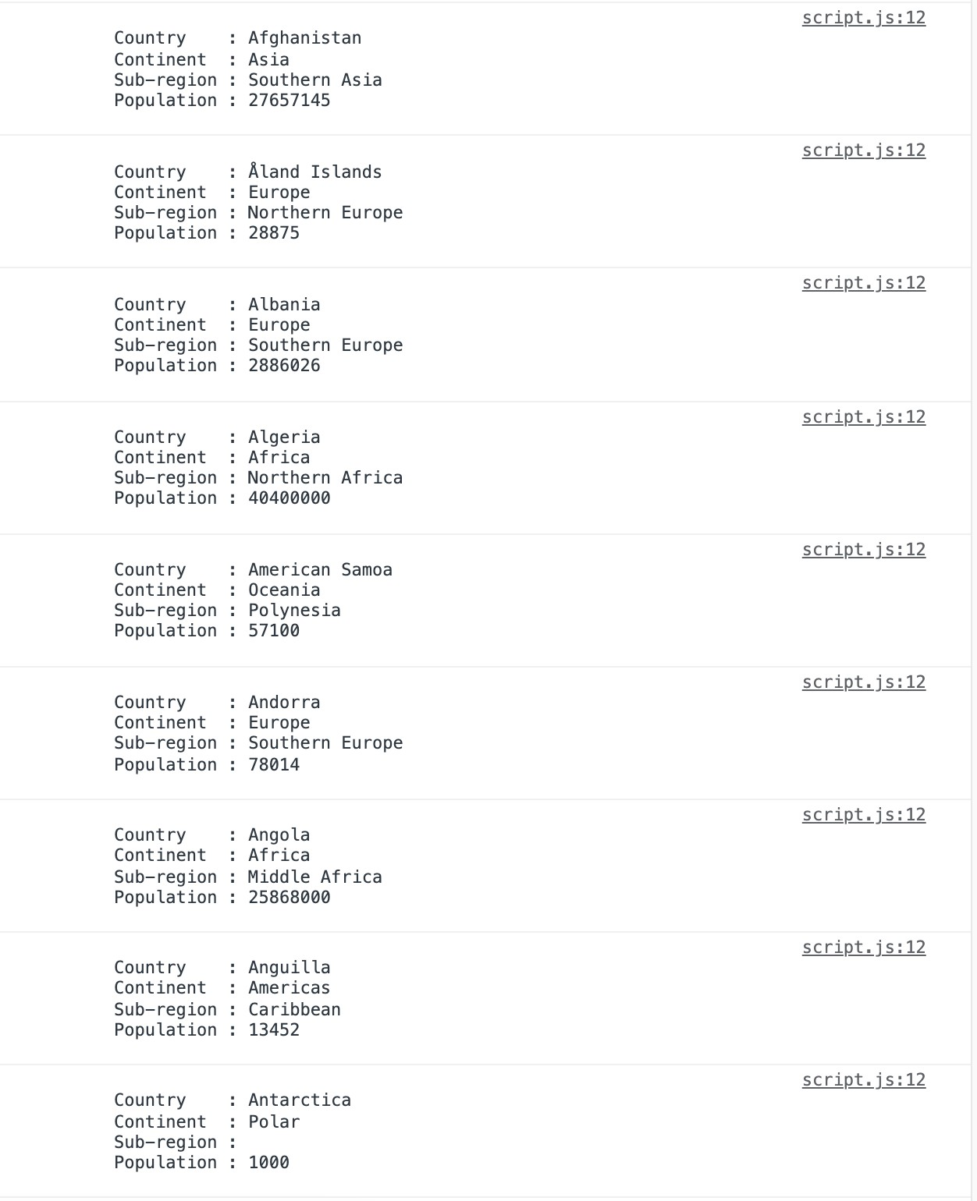

Thank you!!!

Have a good day!!!